Create a linked list of four nodes where new nodes get added to the tail. After the list is full, new items are added to the left (tail), and the head node is dropped to maintain a size of 4.

Each node should contain an integer as value and a pointer that always points to the node on the right.

Your list should accommodate 4 nodes, and any new node should overwrite the oldest one. (In the following examples, only the value of the link is shown.) For example, if you initially have 11, 22, 33, and 44, the list should look like this:

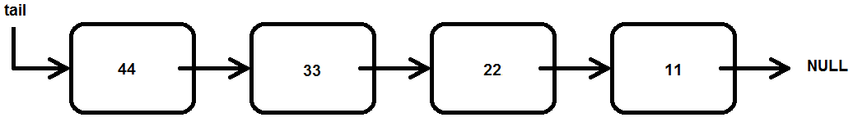

Now, if you add a 55, it should move all nodes over to the right, drop the 11, and you should get:

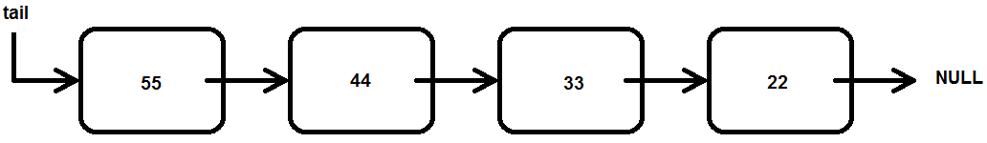

Similarly, adding 66 should result in:

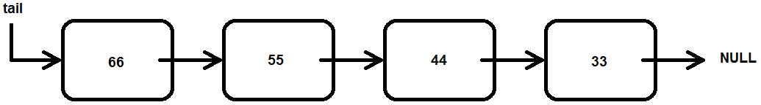

Write the entire code, including the necessary header files, a main() function and the following two functions:

**static void addNode(int number);**

**static void printAllNodes(void);**

**int main(void)**

**{**

**addNode(11);**

**addNode(22);**

**printAllNodes();**

**addNode(33);**

**addNode(44);**

**printAllNodes();**

**addNode(55);**

**printAllNodes();**

**addNode(66);**

**printAllNodes();**

**addNode(77);**

**printAllNodes();**

**}**

**static void addNode(int number)**

**{**

**// Add code here**

**}**

**static void printAllNodes(void)**

**{**

**// Add code here**

**}**

Your output should look something like this:

**Adding 11:**

**Adding 22:**

**22 11**

**Adding 33:**

**Adding 44:**

**44 33 22 11**

**Adding 55:**

**55 44 33 22**

**Adding 66:**

**66 55 44 33**

**Adding 77:**

**77 66 55 44**